**Use Cases**

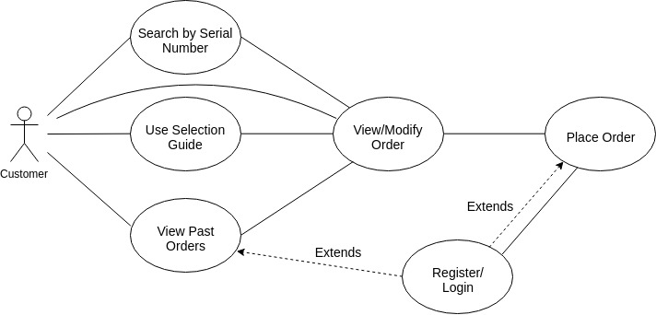

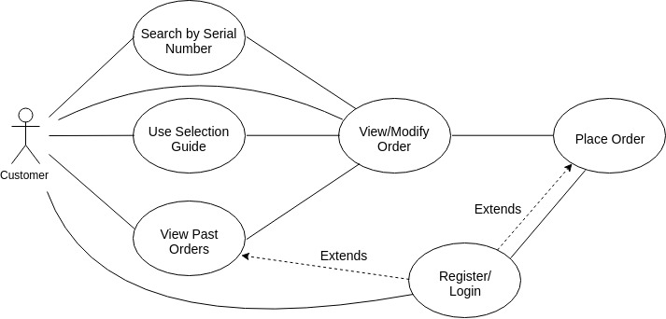

NOTE: I added an extra solid line from customer to login because it made sense to me. You choose whichever version makes everyone happiest!

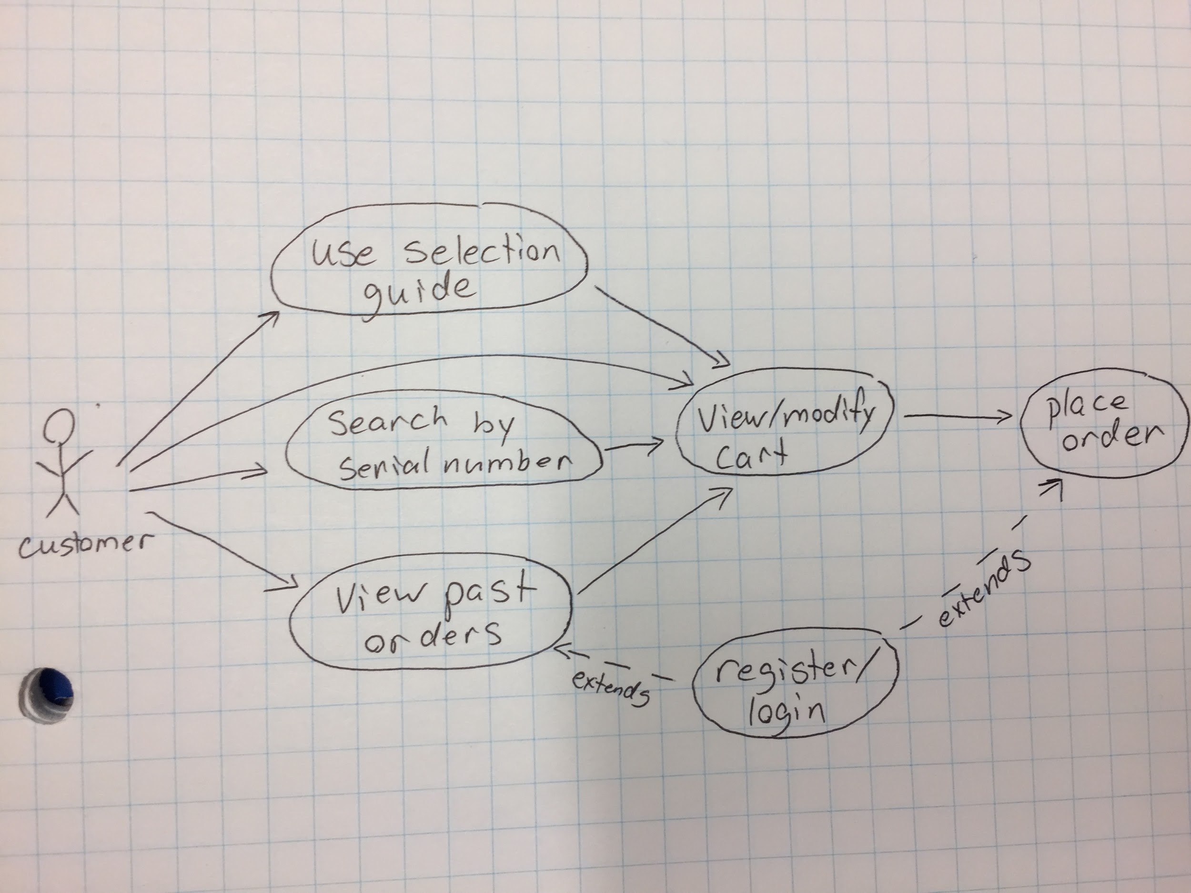

List of use cases, please write use case in pages below.

1.Register/login (Geoff)

2.add item using serial number(oleg)

3.add item using selection guide (using questionnaire) (Marcin)

4.add item using past orders(Bo)

5. View/modify order/cart (Eric)

6. place order ( Emmanuel )

Appendix : [template]

**Register/Login** **3**

**Add Item Using Selection Guide** **4**

**Add item using serial number** **5**

**Add item using past orders** **6**

**View/Modify cart** **7**

**Place Order** **9**

## Register/Login

* Allows the user to create a customer account on the App

**Actors**

* Client using the paint App

**Preconditions**

* Not logged in
* Or not registered under a specific username

**Post Condition**

* The client will have access their list of previously placed orders
* The client will be able to complete the order process by including the place order use case

**Flow of Events**

1. Selects login/register button (Alternate Path a)
2. Selects register as new user button
3. Is redirected to new user form
4. Fills out new user form
5. Returns to the previous page they were on, and now the client can include View Past Orders and Place Order use case.

**Alternate Path**

a)

1. Chooses to fill in previously created user information to complete login
2. Returns to the previous page they were on, and now the client can include View Past Orders and Place Order use case.

Note: during any step, the user can exit the process and register at a later time.

## 

## Add Item Using Selection Guide

* Allows the user to use the Selection Guide to suggest a product to them

**Actors**

* User

**Preconditions**

None

**Post Condition**

* The user will add at least one item to cart that was suggested by the selection guide

**Flow of Events**

1. The user selects the Selection Guide from the starting menu.
2. The system asks the user a series of questions to offer a suggestion on paint to order. This question list is TBD, but some questions may be:  
    - Where will the paint be used? (Outdoors/Indoors)  
    - What type of material is to be painted? (Vinyl, wood etc.)  
    - What colour would you like the surface to be? (user may be provided a swatch to pick a colour)
3. The user answers all the questions that the system proposes to them.
4. The system provides at least 3 suggestions on a paint for the user according to the answers given to the Selection Guide.
5. The user selects one or more of the paints suggested by the Selection Guide and adds them to cart.
6. The system adds the paint(s) to the cart and takes the user to the “view/modify order” page.

**Alternate Path**

* During any step the user can exit the Selection Guide and not add an item to cart.
* If the user wants to change an answer they provided previously, they can return to the previous question by using a back button

## 

## 

## Add item using serial number

* Allows the user to add an item to order using the items serial number

**Actors**

* User

**Preconditions**

* User knows the serial number of a desired item

**Post Condition**

* An item will be added to the order contents

**Flow of Events**

1. User enters serial number
2. User views the paint information
3. User selects the color and quantity of the paint
4. User add paints to order

**Alternate Path**

During any step the user can exit the process and not add an item to cart.

## Add item using past orders

* Allows the user to make an order consisting of modified past orders and new added items

**Actors**

* Customer

**Preconditions**

* User is a registered customer and is logged in
* User has made an order in the past

**Post Condition**

* User’s desired items will be added to cart

**Flow of Events**

1. User clicks the past order button
2. User’s list of past orders are displayed
3. User clicks a specific past order
4. Screen displays list of items from the past order (and the location it was ordered to?)
5. User scrolls through the list of the items
6. User adds desired items (from the past order) to the new cart
   1. User adds (to the cart) the same quantity and color of the paint from the past order
   2. Modified quantities
   3. Different color of the same brand

**Alternate Path**

During any step the user can exit the process and not add an item to cart.

## View/Modify cart

* Allows user to view and adjust their order prior to completion

**Actors**

* User

**Preconditions**

* User is already logged in
* User has finished browsing
* At least one product has been added to cart

**Post Condition**

* Order ready to be sent to store for completion

**Flow of Events**

1. User is presented with a list of the item(s) they have added to their cart
2. User may adjust quantities of any item in their cart by hitting (+/-) to increment/decrement, or manually entering a quantity.
3. In cases where item is a can of paint, there will be an option to add a different sized can of the same paint.
4. User may also remove an item from their cart completely by clicking the (remove) option attached to each item, or may remove all items by clicking (empty cart)
5. User may also return to browsing time to add new items to cart
6. When user is satisfied, and there is still at least one item they wish to purchase, they select the “Place order” option
7. Since user is logged in, order proceeds to Place Order, which is a separately defined use-case

**Alternate Flow**

If the user has removed all items from cart before step 6, or has chosen to view their cart before adding any items to it (precondition of having at least one item has not been met), the cart will be displayed as empty and the “Place order” option will not be available. User must return to browsing and add at least one item before this action is possible.

1. Cart is empty so “Place order” option is greyed out. Attempting to click it yields a “cart is currently empty” error message. User returns to browsing to add an item before returning to cart (there is a separate use-case for each of the three methods in this process)
2. User resumes at step 6 in above Flow of Events.

If the user is not currently logged in, they may still have a cart with items added to it and be attempting to proceed with their order. In this case, the above use case will take an alternate path from step 6.

1. User has attempted to place an order but is not currently logged in. User is instead redirected to register/login screen (there is a separate use case for this process).
2. After completing the register/login process, the user is returned to step 7 with the appropriate pre-condition satisfied. They are then prompted to select a store location as normal

## Place Order

* Allows the user order Paint on cart

**Actors**

* User

**Preconditions**

* User is Registered & Logged in
* User has Paints on the cart

**Post Condition**

* Items in the charts are Ordered.

**Flow of Events**

1. User select store location for order pickup.
2. A scroll list of stores are displayed .
3. Store contact information is displayed .
4. User selects date and time for order pickup .
5. A calendar of available pickup date is displayed .
6. Order cancellation information is provided .
7. The order detail is redisplayed.
   1. The paints in the charts are displayed
   2. Pickup time and location are displayed
   3. Cancellation information are displayed
8. User selects Confirm order.
9. Order information is sent to the pickup location

**Alternate Path**

During the process, User could decide to go back and modify orders.

Template

**Enter Boat in Race**

* Allows the user to enter a boat into a race.

**Actors**

* Race Officer

**Preconditions**

* Details of the relevant boat have already been entered
* Details of the relevant race have already been entered
* The boat is not already entered in the race

**Post Condition**

* The boat will be entered in the race

**Flow of Events**

The user selects the race button

1. A scrolling list of races is displayed
2. Include Select from list (race)
3. The rate details are displayed
4. The user selects the add button
5. A scrolling list of boats is displayed (this is restricted to boats that are eligible to enter the selected race)
6. Include Select from list (boat)
7. The race details are re displayed (with the selected boat added)